

Elections in the United States

In the United States the President is elected by an electoral college for a maximum of two terms. He is elected in November for four years. The new President is officially in office in January, the following year.

In the United States there are two political parties: The Republicans and the Democrats. The emblem of the Democrats is the donkey. The Democrats is in favour of state intervention in economic and social affairs. The emblem of the Republicans is the elephant. The Republicans are in favour of economic liberalism and defend the rights of individuals against too powerful a central government
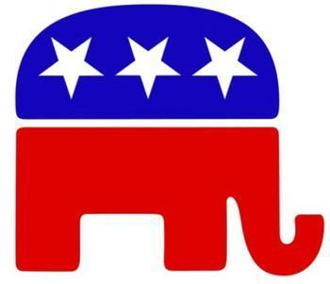
The emblem of the Republicans

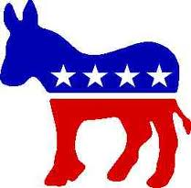
The emblem of the Democrats

Corrected by Lea Martinho and Chloé Roux; Written by SandraHocquet,Myléna Ruffra and Antoine Vincent

Vocabulary:

Help!
Vocabulary

The Repulicans | Les Républicains
The Democrats | Les Démocrates
An electoral college | Un collège électoral
Officially in office | Officiellement en fonction
The Donkey | L'âne
The Elephant | L'éléphant
Economic liberalism | le libéralisme économique
Powerful | Puissant
The Rights | Les droits
Against | Contre

Links:

http://www.usflag.org/

http://squareonepolitics.wordpress.com/2012/07/

http://en.wikipedia.org/wiki/Republican_Party_(United_States)

